Steps to install LEMP on centos 7

Step 1: Install Nginx

To add the CentOS 7 EPEL repository, open terminal and use the following command:

sudo yum install epel-release

step 2:install Nginx using the following yum command:

sudo yum update

yum install nginx

step 3: Once it is installed, you can start Nginx on your VPS:

systemctl start nginx

systemctl enable nginx

Open in a web browser:

<http://server_domain_name_or_IP/>

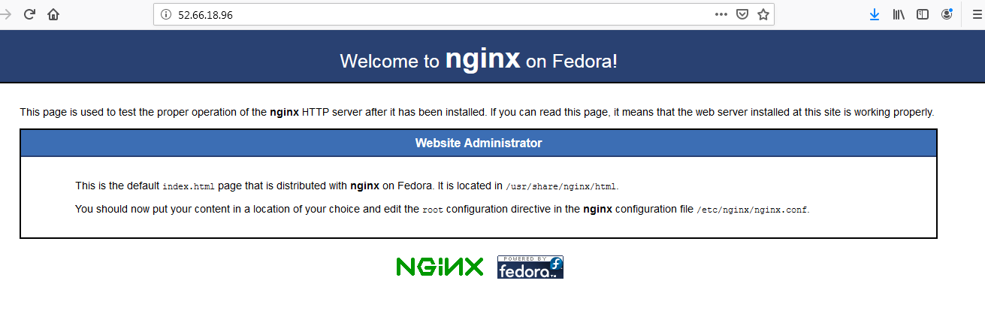

Install Mysql on nginx

Step 6:before you install mysql use below command to update and install wget.

sudo yum update

yum install wget

Step 7:MySQL must be installed from the community repository.

---------------------------------

wget http://repo.mysql.com/mysql-community-release-el7-5.noarch.rpm

sudo rpm -ivh mysql-community-release-el7-5.noarch.rpm

yum update

------------------------------

step 8:Install MySQL as usual and start the service.

sudo yum install mysql-server

sudo systemctl start mysqld

step 9:Run the mysql_secure_installation script to address several security concerns in a default MySQLnstallation.

sudo mysql_secure_installation

------------------------------

step 10:To log in to MySQL as the root user:

mysql -u root -p

---------------------------------

Enter the password and type Exit to come out from mysql.

**Installing php 7.2 on centos (NGINX)**

Step1: The first thing that we will do is install additional CentOS repo which contains required packages for PHP v7.1

wget http://rpms.remirepo.net/enterprise/remi-release-7.rpm

rpm -Uvh remi-release-7.rpm

step 2:Enable php71 repository which is disabled by default:

yum install yum-utils -y

yum-config-manager --enable remi-php71

step 3: Secondly, install PHP package:

yum --enablerepo=remi,remi-php71 install php-fpm php-common

step 4: Install common modules:

yum --enablerepo=remi,remi-php71 install php-opcache php-pecl-apcu php-cli php-pear php-pdo php-mysqlnd php-pgsql php-pecl-mongodb php-pecl-redis php-pecl-memcache php-pecl-memcached php-gd php-mbstring php-mcrypt php-xml

**Configuring Nginx to work with PHP 7**

Configuring Nginx to work with PHP 7

Create a new Nginx configuration file by running vim or [nano](https://www.hostinger.com/tutorials/how-to-install-and-use-nano-text-editor) text editor:

nano /etc/nginx/conf.d/default.conf

step5: Input this code:

server {

listen 80;

server_name your_server_ip;(add public ip instead of your_server_ip)

# note that these lines are originally from the "location /" block

root /usr/share/nginx/html;

index index.php index.html index.htm;

location / {

try_files $uri $uri/ =404;

}

error_page 404 /404.html;

error_page 500 502 503 504 /50x.html;

location = /50x.html {

root /usr/share/nginx/html;

}

location ~ \.php$ {

try_files $uri =404;

fastcgi_pass unix:/var/run/php-fpm/php-fpm.sock;

fastcgi_index index.php;

fastcgi_param SCRIPT_FILENAME $document_root$fastcgi_script_name;

include fastcgi_params;

}

}

Step 6: Save the file by hitting **CTRL + X** and y enter.

Step 7: change directory to /html

cd /usr/share/nginx/html/

step 8:List out the files and if info.php or index.php is not present create file using below command

vi index.php or vi info.php

Step 9: Save the file by hitting **CTRL + X** Restart Nginx for change to take effect:

systemctl restart nginx

step 10: Now, open **PHP-FPM** configuration:

nano /etc/php-fpm.d/www.conf

step 11: Find and replace these lines:

user = apache to user = nginx

group = apache to group = nginx

listen.owner = nobody to listen.owner = nginx

listen.group = nobody to listen.group = nginx

And, lastly, under ;listen = 127.0.0.1:9000 add this line:

listen = /var/run/php-fpm/php-fpm.sock

step 12: Once again, save the file by hitting **CTRL + X**. And finally, start php-fpm and enable it on boot:

systemctl start php-fpm.service

systemctl enable php-fpm.service

Go to url and search https://ip.info.php

